Block of the Month – Herring Run Quilt Guild
November 2019 – due at the December 2019 Guild Meeting

This month, you will be making 2 simple blocks that go together to make a fabulous quilt!
Fabric Required:
From colorful scraps, cut:
- 25 – 2 1/2" squares (I recommend cutting 2 squares from 12 different fabrics, then 1 from another fabric)
From white or white on white fabric, cut:
- 1 – 6 1/2" square
- 2 – 2 1/2" x 6 1/2" strips
- 2 – 2 1/2" x 10 1/2" strips
Assembly, Block 1:
Using 9 different colored 2 1/2" squares, make a 9 Patch. Press, then add the 2 – 2 1/2" x 6 1/2" strips to the two opposite sides of the 9 Patch. Press. Add the 2 1/2" x 10 1/2" strips to the top and bottom of the 9 Patch. Press, then trim the block to 10 1/2" square.
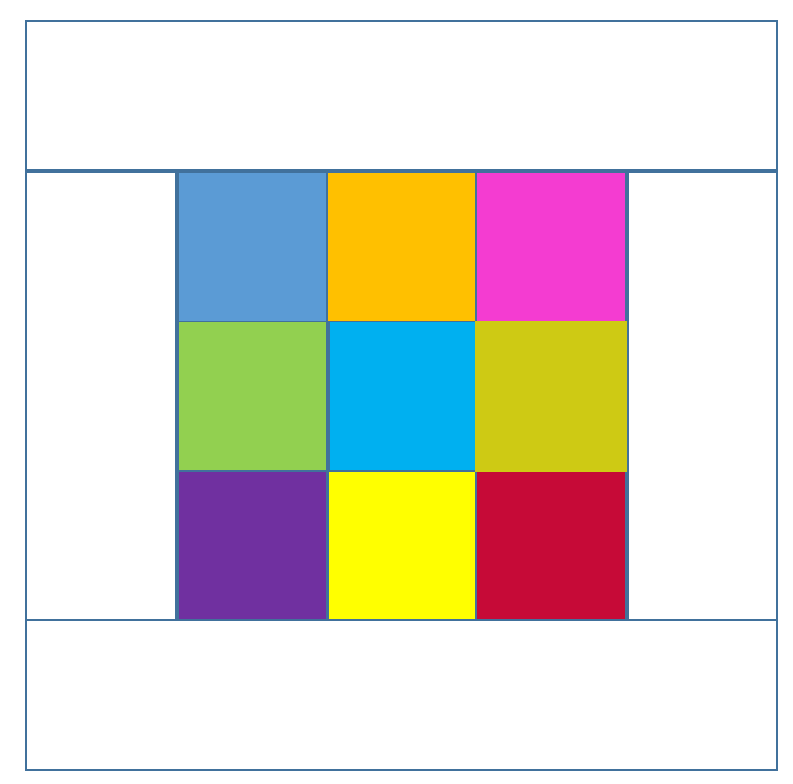
Assembly, Block 2:
Using the remaining 16 - 2 1/2" colored squares and the 6 1/2" white square, lie out the block. Assemble as indicated below, pressing each seam. Trim the block to 10 1/2" square.

